CS1428 Lab 00h

# Name: Section:

Write your name at the top of this sheet. Answer the following questions and turn in this sheet before the end of class. You may use your instructor’s web materials, your book or an internet resource to answer these questions. (100 points) (Not for grade)

1. (10 pts) What environment do we use to develop and compile our C++ programs? What is the name of the compiler our environment uses?

Eclipse

Cygwin

1. (25 pts) Using the Eclipse write a very simple program. It must output your name, today’s date, and your lecture/section number. Name the source file **lab00h.cpp. (**Make sure to include the standard header discussed in lab and to name the file correctly**)** Compile and run it. Print and attach the source code to this work sheet. Upload the source to the homework upload.
2. (10 pts) What is an algorithm?

An algorithm is a well-ordered collection of unambiguous and effectively

computable operations that, when executed, produces a result and halts in a

finite amount of time.

1. (10 pts) What is Computer Science?

Computer science is the study of the design and development of ***algorithms***  to solve a range of important problems. (problem solving)

1. (10 pts) What are some expressions? Make up 6 different, valid, C++ expressions.

++ / - = /=

-- % >> += *=

* + << -= %=

1. (10 pts) What are the steps to start writing a program in Eclipse? What important thing must you always verify is selected? What does the error “Binary Not Found” mean?

New Project (New C++ Project)-> Name -> Cygwin GCC->Finish -> Right Click on Project -> New Source File

Cygwin GCC

Your file hasn’t been saved yet.

1. (10 pts) What is the difference between assembly and machine code?

Machine language is the actual bits used to control the processor in the computer. The processor reads these bits in from program memory, and the bits represent “instructions” as to what to do next. Machine language provides a way of entering instructions into a computer (via switches, punched tape, or a binary file). Assembly language is more human readable view of machine language. Instead of representing the machine language as numbers, the instructions are given names. Unlike a high level language, assembly is very close to machine language.

1. (15 pts) Label the picture. (5 items)

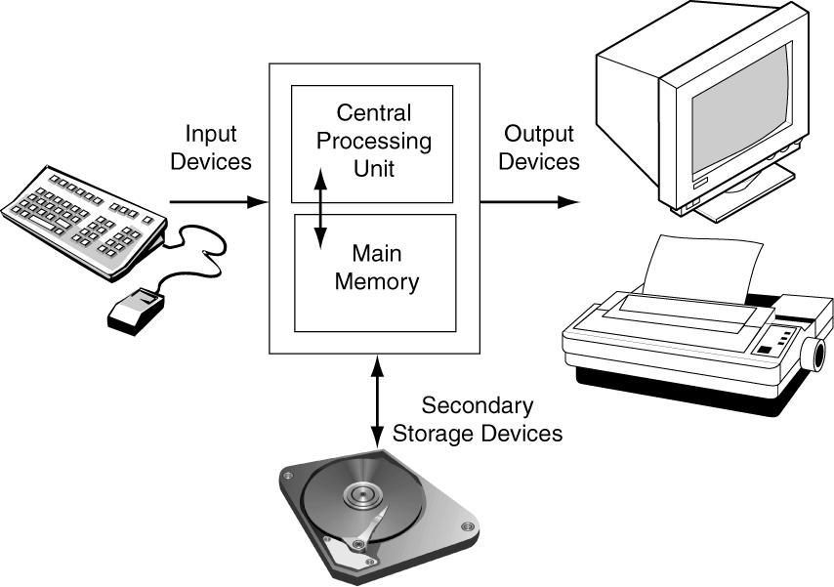

Arithmetic/Logic Unit

Memory Unit

Output Device

Input Device

Control Unit

**Note:** Print and attach a copy of **lab00h.cpp** to this worksheet along with the output as well. **UPLOAD** all source files and program output to my homework folder:

To access my homework folder, Go to [http://www.cs.txstate.edu/~masone /](http://www.cs.txstate.edu/~masone%20/) and click on the link for your lab section. Login with your Texas State user ID and password, browse for the file, and then click on submit.